

**Atmanand Saraswati**

**Science College**

**Bachelor of Computer Application**

**Programme**

**(T.Y.B.C.A. SEMESTER - V)**

**Project Report**

**On**

**Online Bus Booking Management System**

**(Khodal Tour & Travels)**

**Submitted By:**

**Name: Sutariya Krishna Rameshbhai**

**Exam No.: 6663**

**Roll No.: BCA21080**

**Guided By:**

**Mrs. Chitra Gohil**



**Atmanand Saraswati**

**Science College**

**C E R T I F I C A T E**

This is to certify that Mr./Ms. **_____Sutariya Krishna Rameshbhai _____** examination number **___6663___** has satisfactorily completed his / her minor project work entitled **_____Online Bus Booking Management System (Khodal Travels)_____** as partial fulfilment of requirements for T.Y.B.C.A. Semester – V, during the academic year 2023-24.

Date: 17/06/2021

Place: Surat (Dr. Shailesh C. Padsala)

I/C Principal

Atmanand Saraswati Science College,

Surat

**ACKNOWLEDGEMENT**

I would like to express my gratitude and appreciation to all those who

gave me the possibility to complete this report. Special thanks is due to my

supervisor Mr. Hazami bin Che Hussain whose help, stimulating suggestions

and encouragement helped me in all time of fabrication process and in writing

this report. I also sincerely thanks for the time spent proofreading and correcting

my many mistakes.

I would like to express my gratitude and appreciation to all those who gave me the possibility to complete this project. Special thanks are to my mentor **Chitra Gohil** whose help, stimulating suggestions and encouragement helped me in all time of fabrication process and in writing this report. I also sincerely thanks for the time spent proofreading and correcting my many mistakes.

I would also like to acknowledge with much appreciation the crucial role of the staff in B.C.A. Laboratory, who gave me a permission to use the lab equipment and also the machine and to design the drawing and giving a permission to use all the necessary tools in the laboratory.

Many thanks go to the all lecturers who have given their full effort in guiding me in achieving the goal as well as their encouragement to maintain our progress in track. My profound thanks go to all classmates, especially to my friends for spending their time in helping and giving support whenever I need it in fabricating my project.

**ABSTRACT**

I would like to express my gratitude and appreciation to all those who

gave me the possibility to complete this report. Special thanks is due to my

supervisor Mr. Hazami bin Che Hussain whose help, stimulating suggestions

and encouragement helped me in all time of fabrication process and in writing

this report. I also sincerely thanks for the time spent proofreading and correcting

my many mistakes.

Online Bus Booking Management System is a Web based application that works within a Centralized network. This project presents a review on the software program **“Online Bus Booking Management System”** as should be used in a bus transportation system, a facility which is used to Reserve seats and different types of route enquiries used on securing Quick reservations.

**OBBMS** is built for managing and computerizing the traditional database, Ticket booking and tracking bus and travel made. It maintains all customer details, bus details, Reservation details. In addition, PHP Hypertext Pre-processor (PHP) Language was used for the front- end of the software while the back end was designed using MySQL.

The software achieved is capable of improving the customer hand and relationship Management in ITC operations. It is recommended that despite the present functionality of the Designed software, an additional functionality such as the use of E-mail to send tickets should be implemented into the system.

**Table of Content**

|  |  |  |
| --- | --- | --- |
| **Sr. No.** | **Description** | **Page No.** |
| **1** | **Introduction** | **01.** |
| **2** | **Environment Description** |  |
|  | 2.1 Hardware Requirements | **02.** |
|  | 2.2 Software Requirements | **02.** |
| **3** | **System Analysis and Planning** |  |
|  | 3.1 Existing System and its drawbacks | **03.** |
|  | 3.2 Feasibility study | **04.** |
| **4** | **Proposed System** |  |
|  | 4.1 Scope | **05.** |
|  | 4.2 Project modules | **05.** |
|  | 4.3 Module wise objectives and functionalities | **05.** |
| **5** | **Detail Planning** |  |
|  | 5.1 Data flow diagram | **06.** |
|  | 5.2 Data dictionary | **07.** |
|  | 5.3 Entity – Relationship Diagram | **08.** |
| **6** | **System Design** |  |
|  | 6.1 Input design | **09.** |
|  | 6.2 Output design | **11.** |
|  | 6.3 Screenshots of the system | **13.** |
| **7** | **Software Testing** | **18.** |
| **8** | **Limitations and Scope of Enhancement** | **19.** |
| **9** | **References** | **20.** |

1. **Introduction**

* Online bus booking management system is a system designed primarily for use in tour and travels for manage passenger and employee.
* This system is fully responsive or mobile friendly and have a good-looking user interface.
* Online bus booking management system have contained two panels:
  + Admin panel
  + Passenger panel
* **Admin** :-
  + Login
  + Dashboard
  + View all passenger profile
  + Manage all buses & bus stations
  + Show current booking all buses
* **Passenger** :-
  + Home
  + Registration and login
  + View details
    - Bus
    - Bus station
  + Search or sort by
    - Bus name
    - Bus category
    - Price
  + Book ticket ( max. 6 )
  + Select bus sheets by client manually
  + Print ticket as pdf

1. **Environment Description**
   1. **Hardware Requirements**

* **Server**: 4-core CPU 8GB RAM, 250GB SSD Storage.
* **Client**: Any standard computer or mobile device with internet connectivity.
  1. **Software Requirements**
* **Server**: Windows OS, MySQL, PhpMyAdmin,
* **Client**: Modern web browsers like Chrome, Firefox, Edge, Safari

1. **System Analysis and Planning**
   1. **Existing System and its drawbacks**

Existing System:

The prevailing bus booking management platforms in the current market offer basic functionalities, such as user registration, booking buses, trace tickets, user profile management etc.

Drawbacks:

* + 1. Limited Customization:

User are often restricted to predefined themes and cannot customize the layout or appearance of their tickets extensively.

* + 1. Security Vulnerabilities:

Older bus booking management platforms often face security issues, making them prone to hacks and unauthorized data breaches.

* + 1. Lack of integration :

Modern users prefer platforms that can be integrated with other platforms, which many existing system lack.

* + 1. Performance Issues:

With increasing user loads, the system often becomes sluggish. This is mainly due to the non-scalable architecture of many existing system.

* 1. **Feasibility study**

In the conception of our new bus booking management platform, a feasibility study was carried out to determine the viability of the project:

* + 1. Technical Feasibility:

With the use of modern languages like PHP and MySQL, the proposed system is technically feasible. The open-source nature of these technologies ensures that the platform can easily integrate newer feature in the future.

* + 1. Economic Feasibility:

Given that the project leverages open-source tools and platforms, the initial cost is significantly reduced. The use of cloud-based solutions can ensure that the operating costs remain manageable, with the flexibility to scale as required.

* + 1. Operational Feasibility:

The proposed system is designed with a user-centric approach, ensuring that the transition from existing systems is smooth. Training resources and documentation will be provided, making it operationally feasible for both technical and non-technical users.

1. **Proposed System**
   1. **Scope**

The platform aims to provide a seamless experience for users to search buses, book ticket, trace tickets by booking id, and maintain their profiles.

* 1. **Project Modules**

1. Search Bus Module
2. Book Bus Module
3. Trace Ticket Module
4. Contact Module
5. Profile Update Module
   1. **Module wise objectives and functionalities**
6. Search Bus Module :

This module is responsible to search the buses by passenger’s choice and search bus with their journey date and return date (optional).

1. Book Bus Module :

This module provides functionalities related to creating, reading, updating, and deleting (CRUD) bus booking.

1. Trace Ticket Module :

This module provide options for passengers to view and print booking details and tickets of particular booked tickets.

1. Contact Module :

This module is responsible to contact for administrator to the particular website or owner of projects.

1. Profile Update Module :

This module provide options for passengers to update and modify profile details, change the password and view booking or cancel booking details.

1. **Detail Planning**
   1. **Data flow diagram**

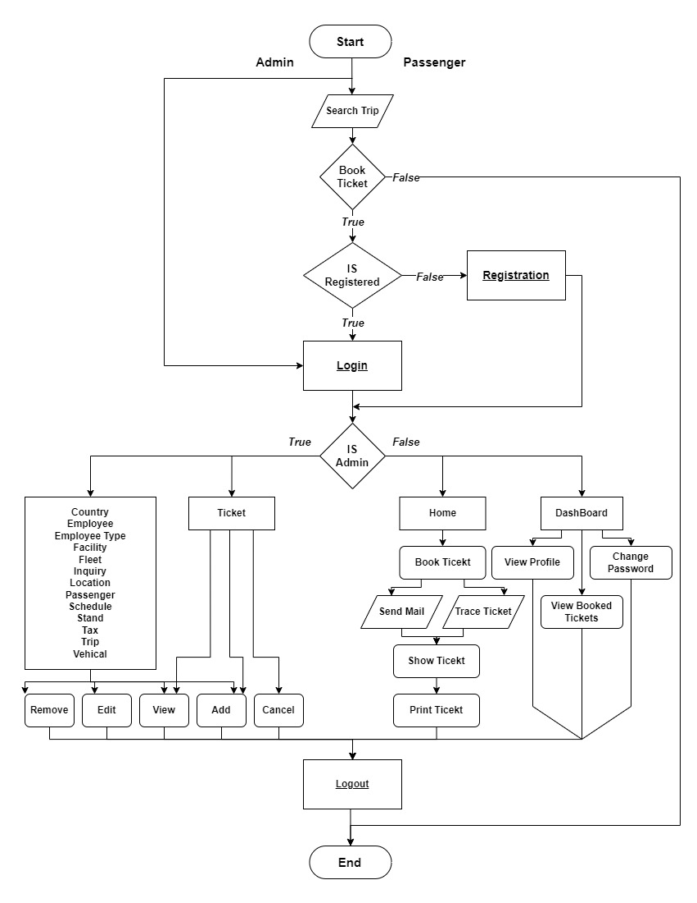

* 1. **Data Dictionary**

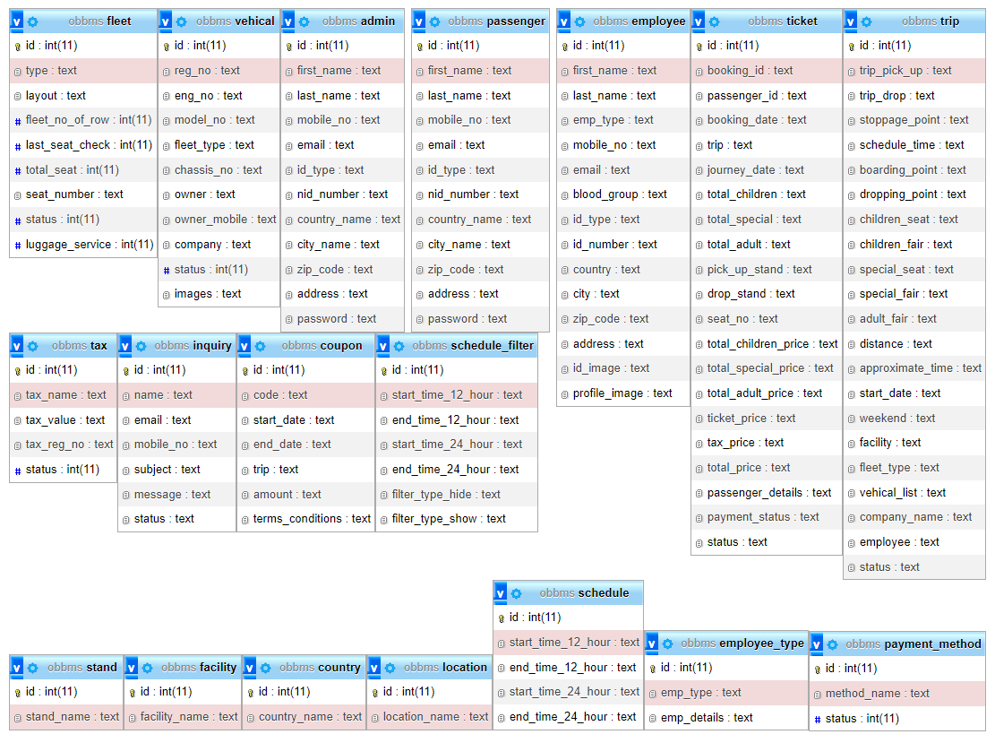

* 1. **Entity – Relationship diagram**

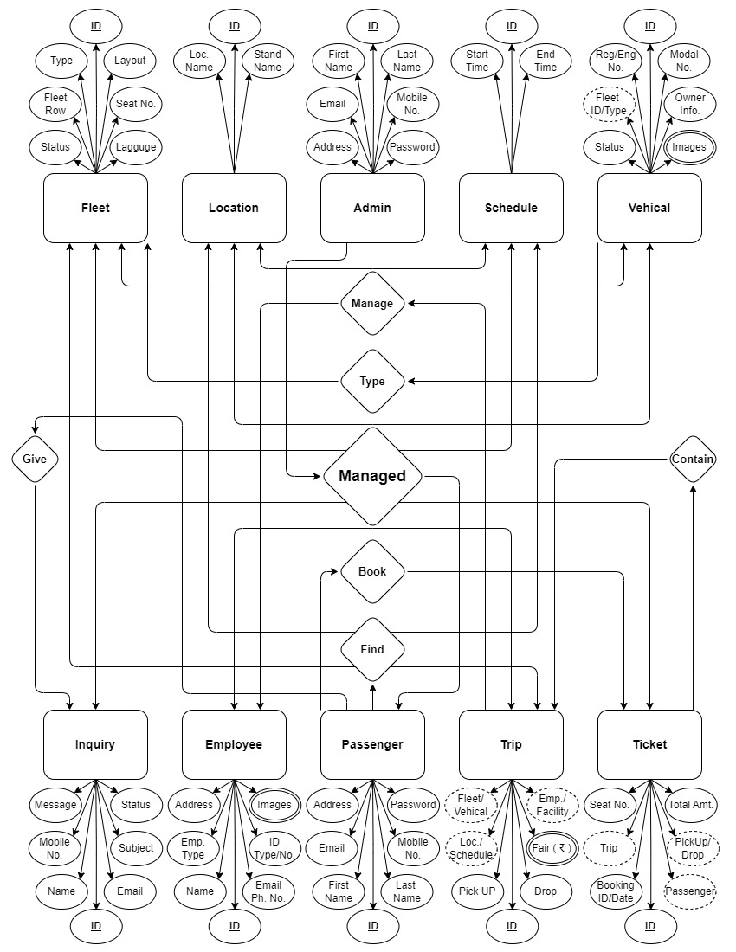

1. **System Design**
   1. **Input Design**

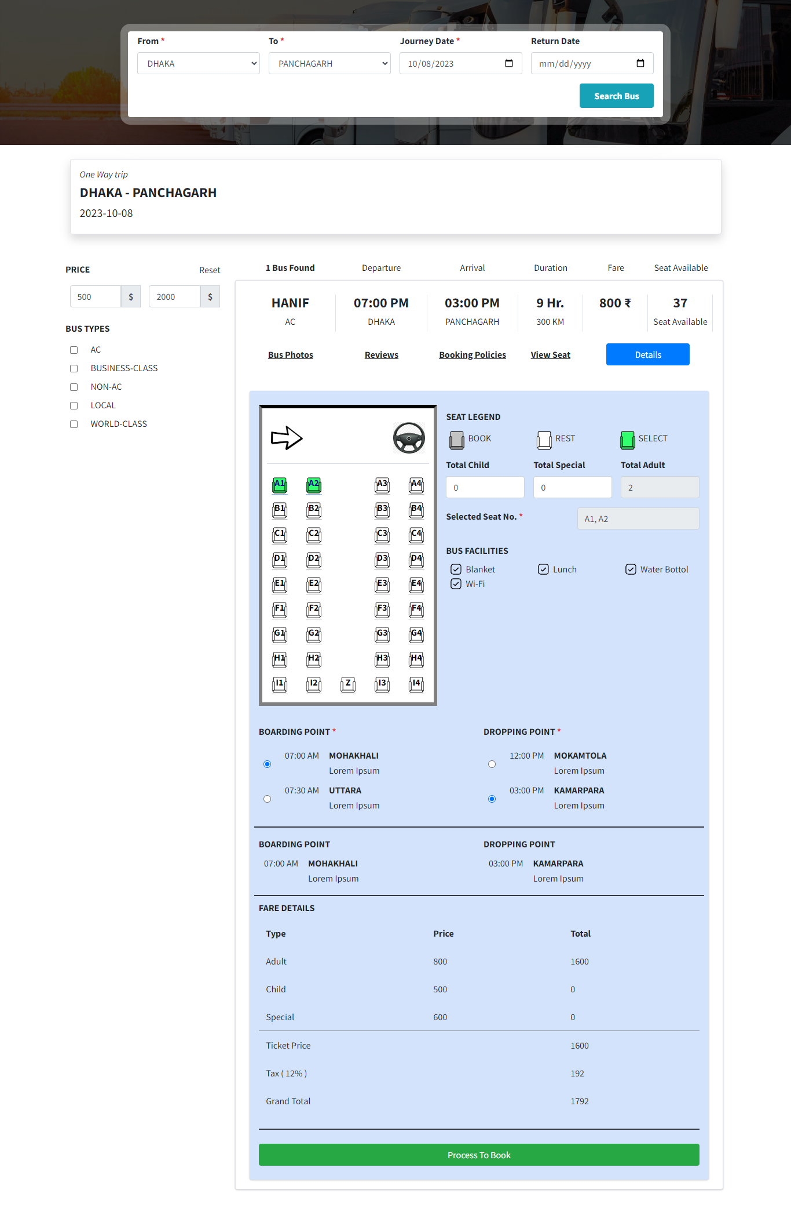

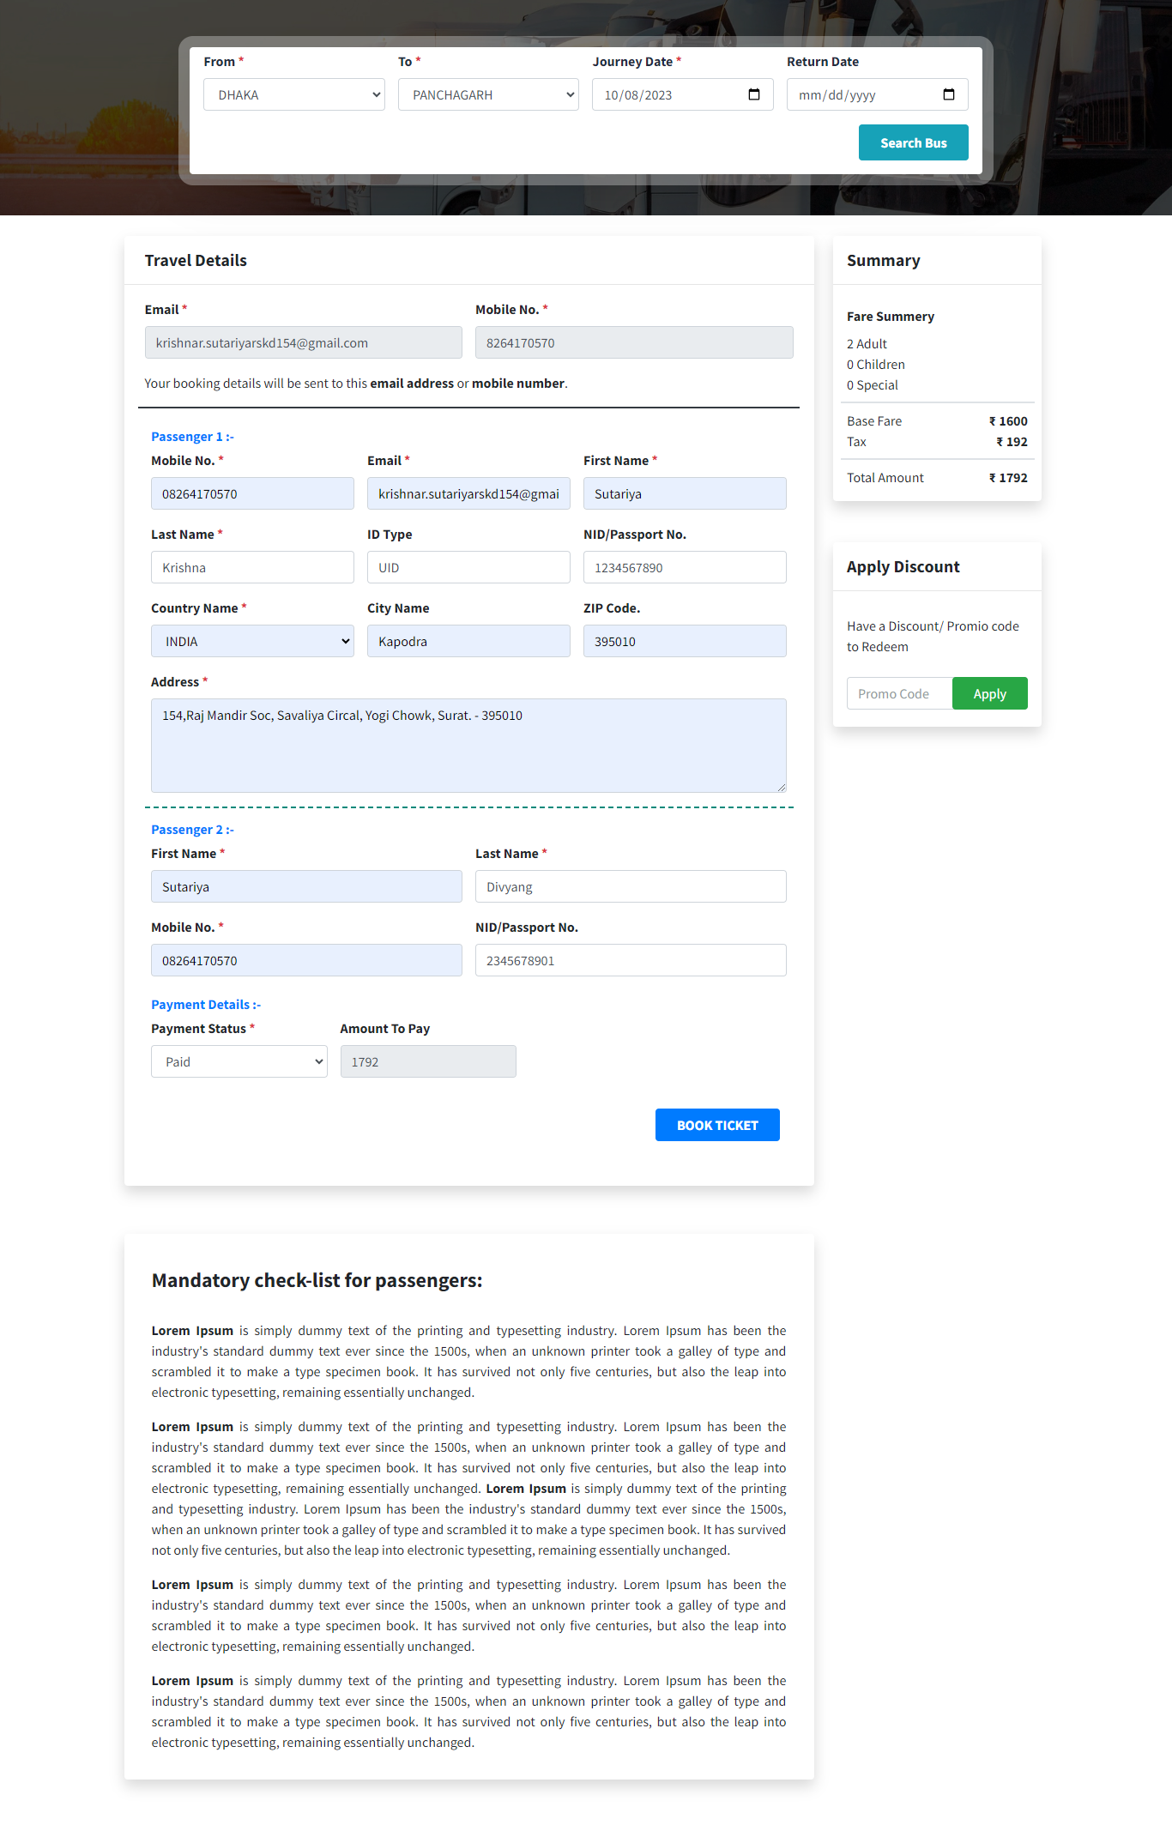

* 1. **Output Design**

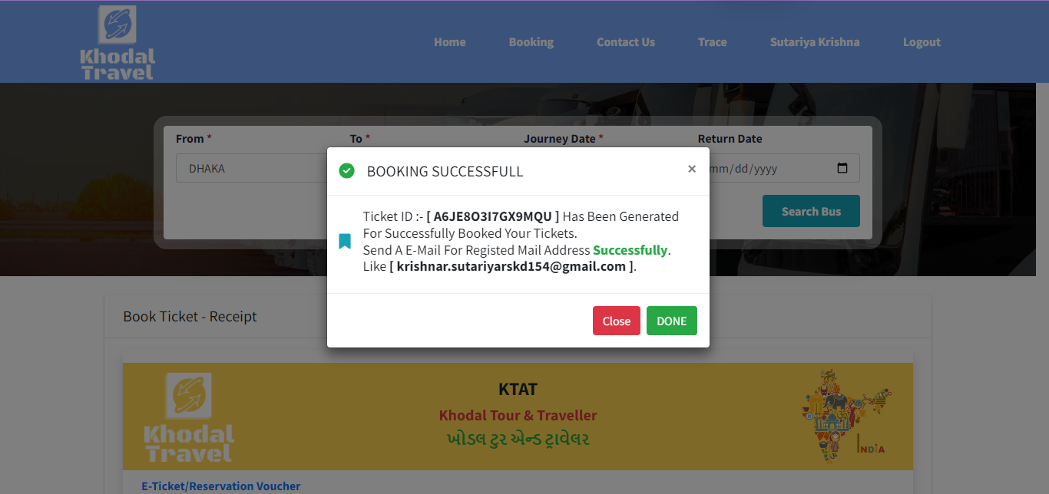

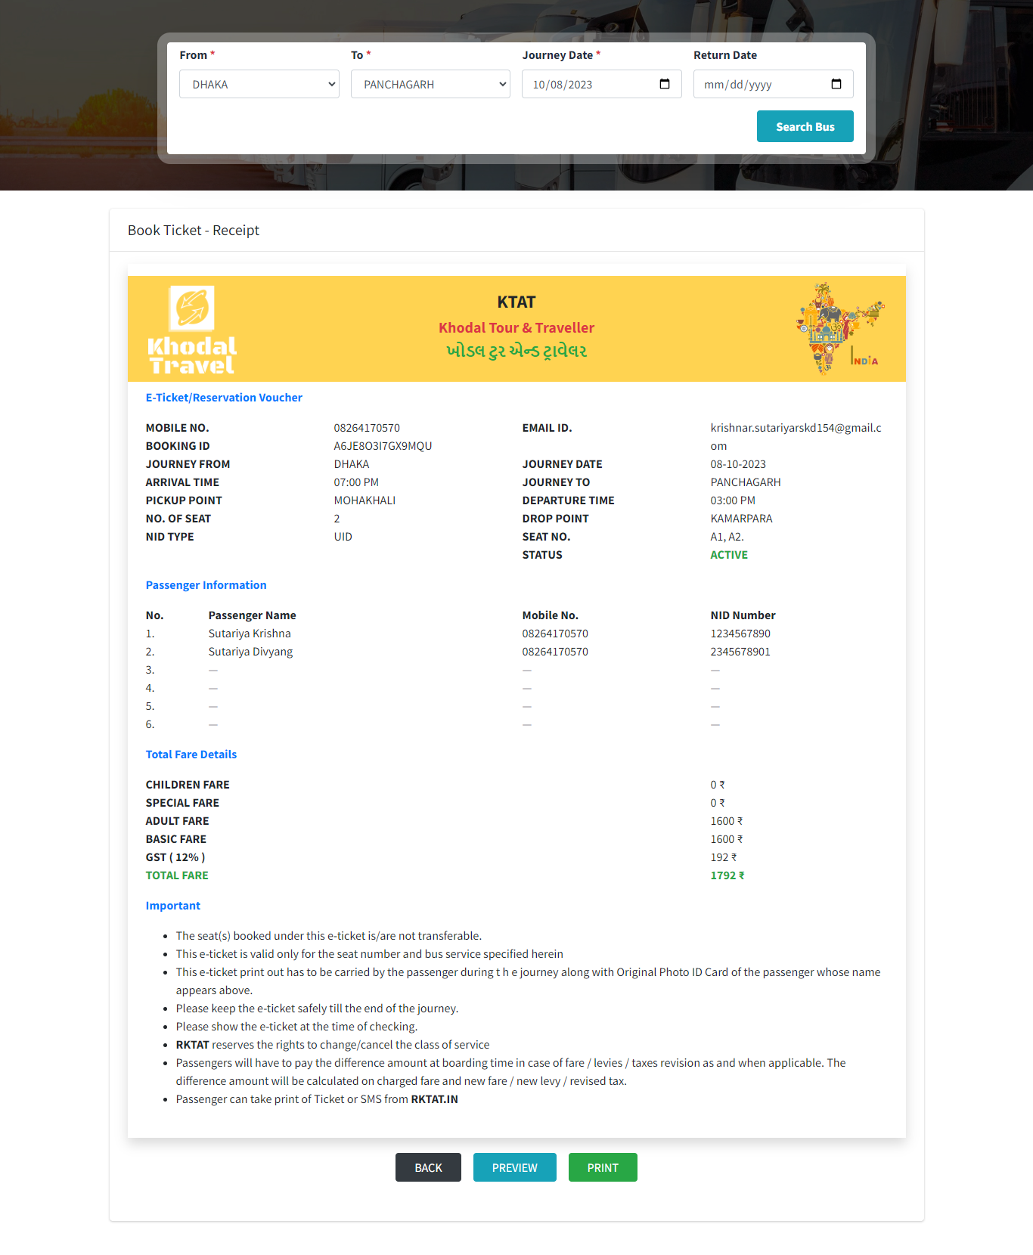

* 1. **Screenshots Of the system**

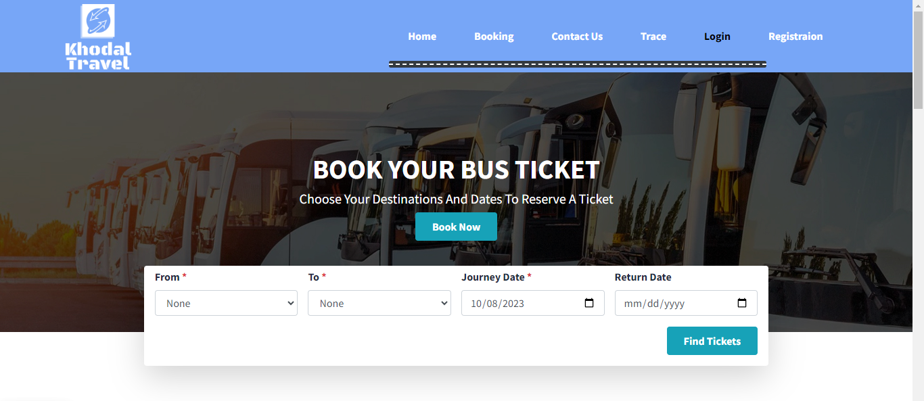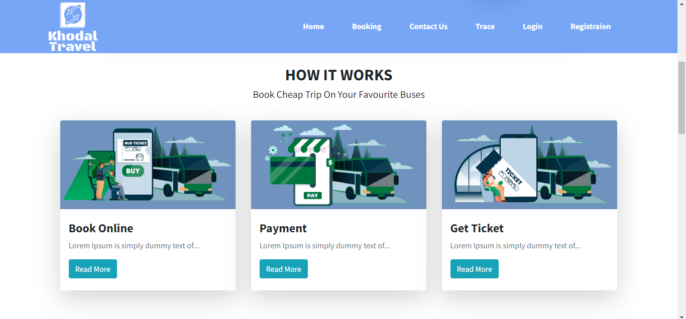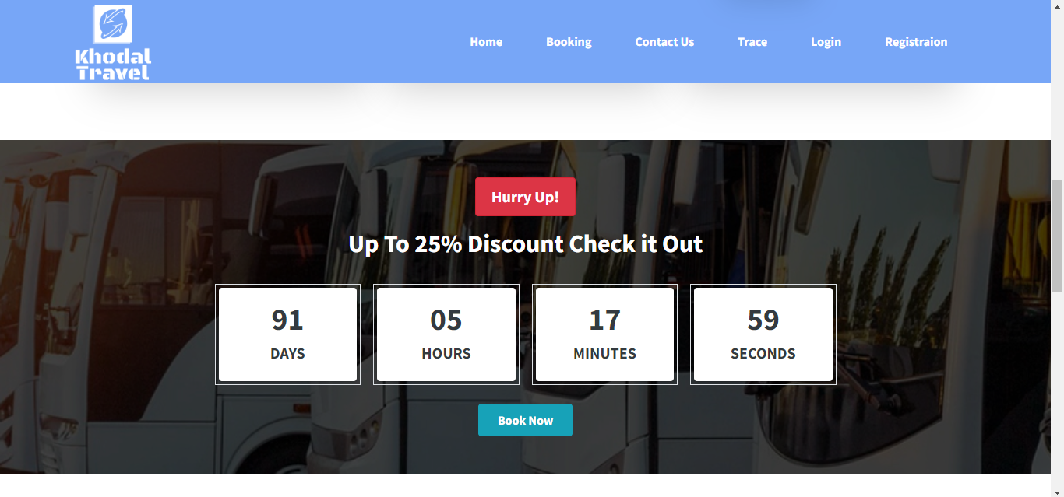

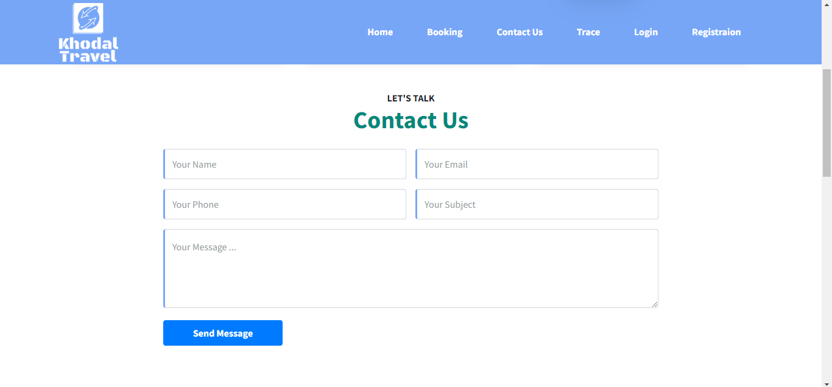

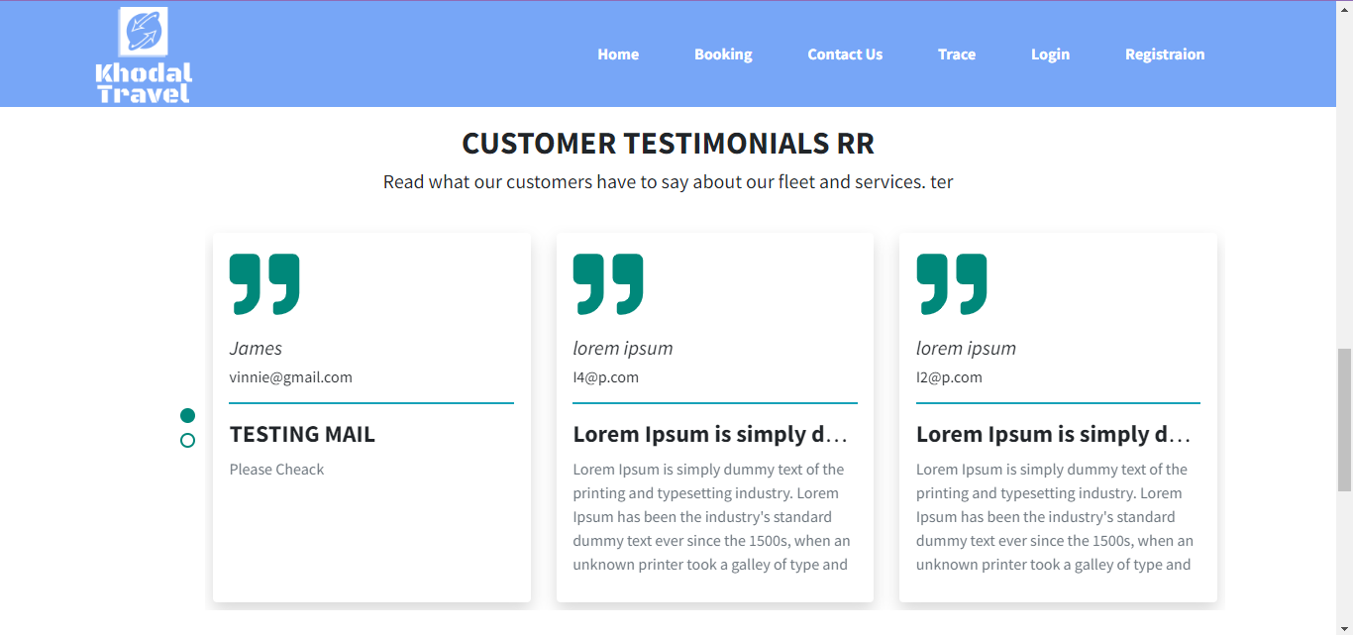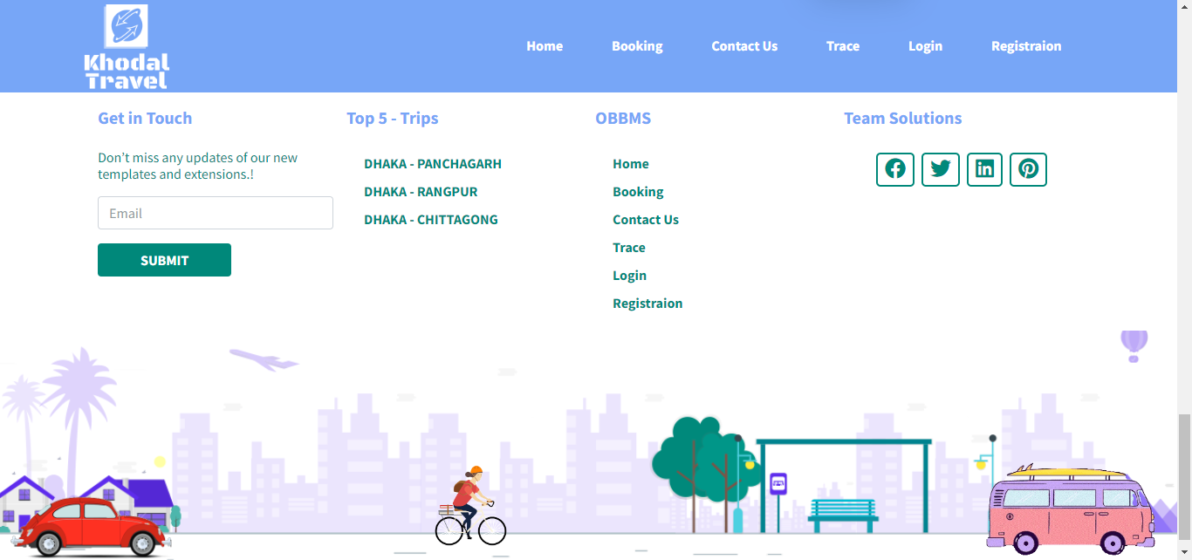

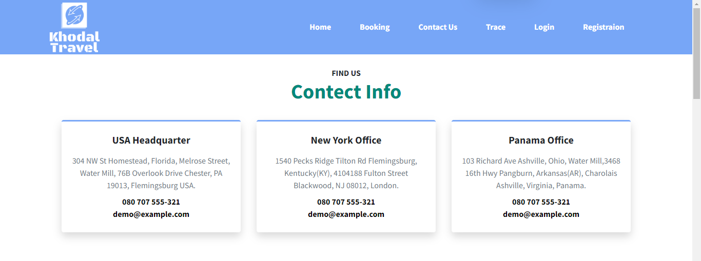

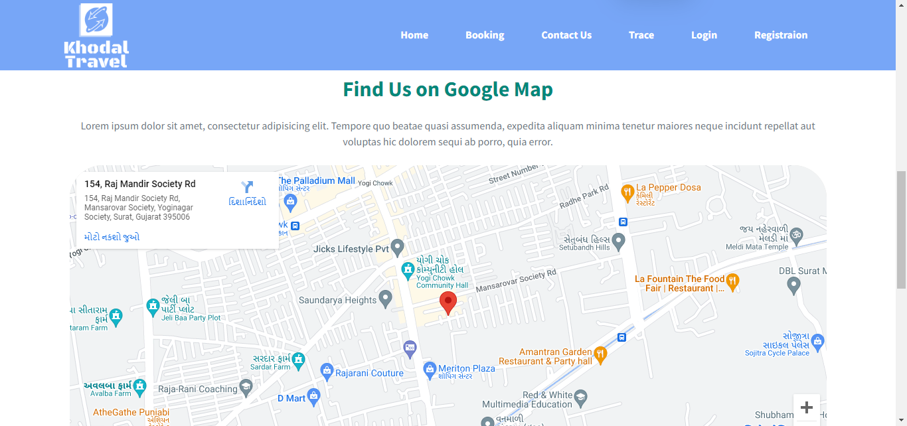

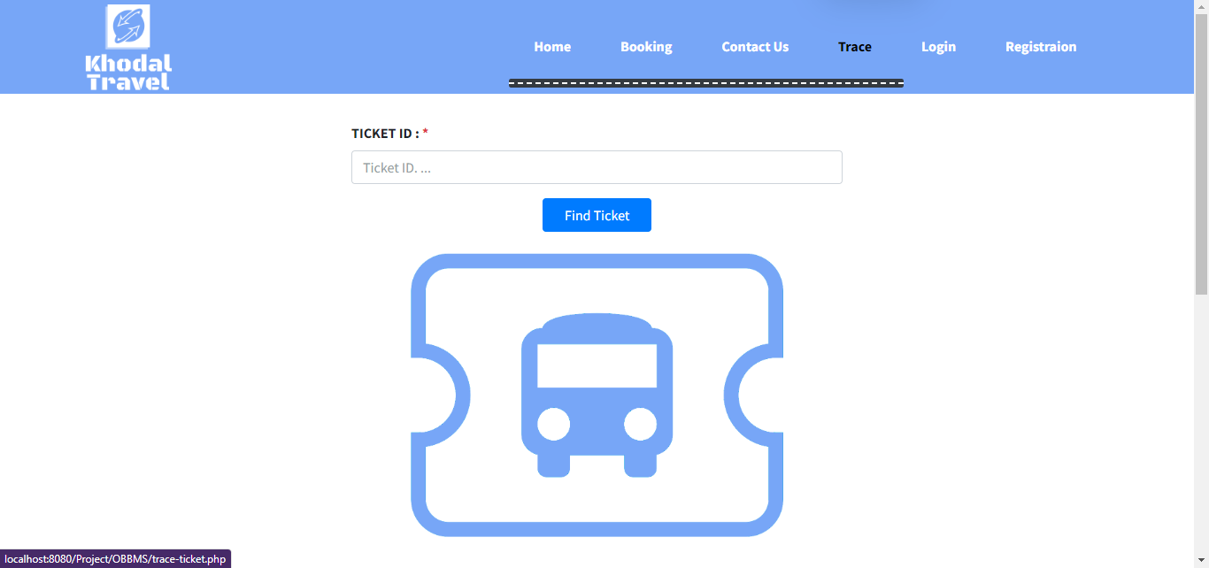

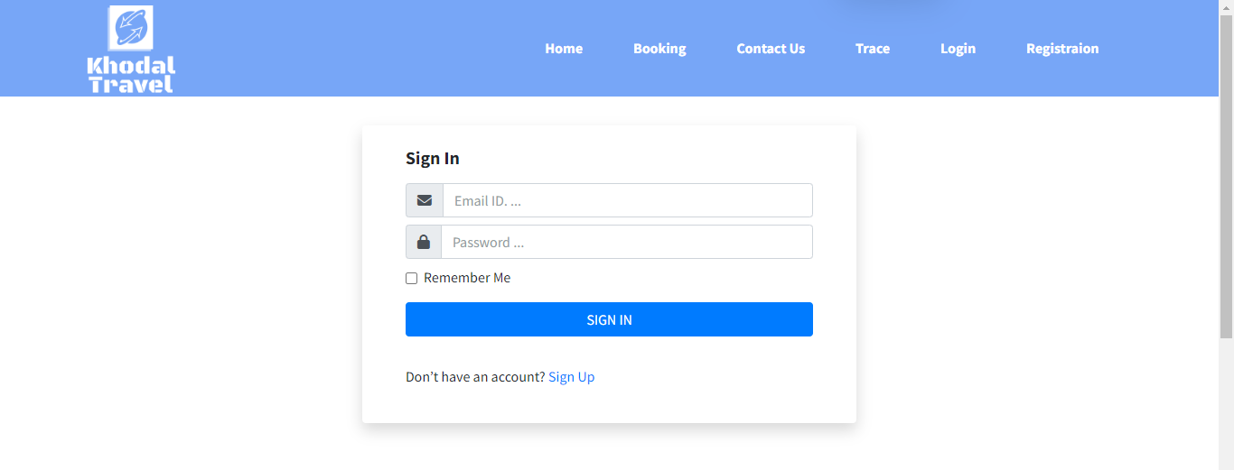

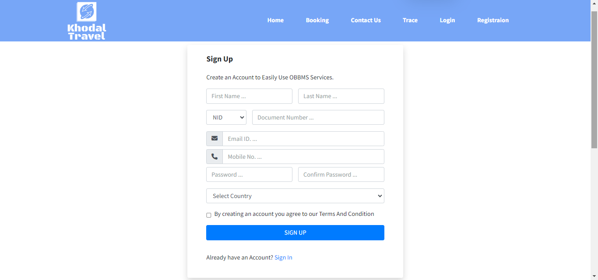

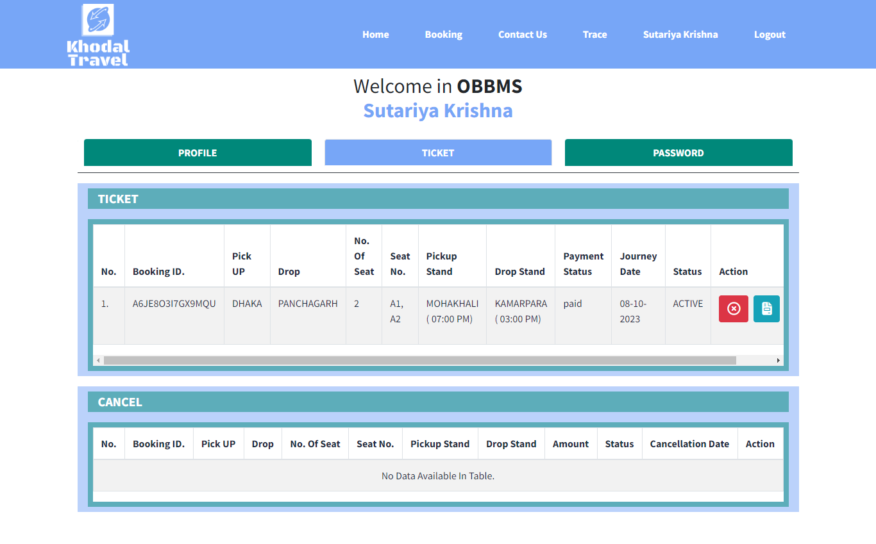

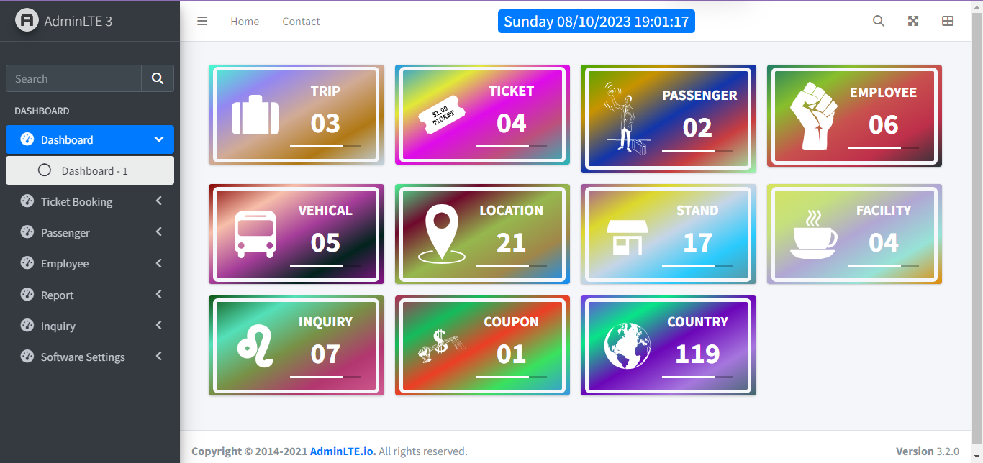

1. **Software Testing**

The Software testing is an essential phase in the software development life cycle. It’s aimed at evaluation an application to detect any discrepancies between the expected output and the actual output of functionalities. For this bus booking management platform.

The bus booking management platform is bug-free, meets the user requirements, and provide a smooth user experience.

1. Unit Testing:

For the User Profile Module, a unit test could verify that the password hashing function return the expected hashed value for given password.

1. Integration Testing:

Ensure that after a successful user registration, the user can immediately log in without issues.

1. Function Testing:

In Booking Bus Module, verify that the ‘Search Bus’ functionality sort the bus as intended.

1. Security Testing:

Test the user authentication process to ensure it’s resistant to SQL injection attacks.

1. **Limitations and Future Scope of Enhancement**

Every software system, especially in its initial phases, will have certain limitations. However, recognizing these limitation and planning for future enhancements is a mark of a mature development process.

* **Limitations** :

1. Feature Limitations:

The current platform might lack search station support in bus booking, restricting users to find multiple places.

1. Integration Limitations:

The platform might not offer integration with popular media platforms or third-party analytics tools in its phase.

1. Customization Restrictions:

Users might have limited option for customizing the appearance of their bookings or profiles.

* **Future Scope of Enhancement**:

1. Feature Enhancements:
   1. Customers Support: Future versions can allow to users embed book buses with search, and other trips content in their buses.
2. Advanced Commenting System: Introduce threaded comments to allow users to reply to specific comment, enhancing engagement.
3. Scalability Improvements:

Optimize the system for better performance and ensure it can handle a larger user base.

1. Security Enhancements:

Implement advanced security measures like Two-Factor Authentication (2FA) and regular security audits to ensure the platform is resistant to threats.

1. **References**

Online Documentation:-

* <https://www.google.com>
* <https://chat.openai.com/auth/login>
* <https://bus365demo.bdtask-demo.com>
* <https://stackoverflow.com>
* <https://youtube.com>
* <https://www.000webhost.com>

Project:-

* <https://online-bus-booking-management-system-php.000webhostapp.com>